Name: Suraj Sharma

ID: 109606910

1. Take your social network data set, compute the following values.

a. For each edge compute the overlap of neighborhood. That is, for an edge uv, take

|N(u) ∩ N(v)|

|N(u) ∪ N(v)| ,

where N(u) is the set of neighbors of u, and |S| takes the number of elements in the set S.

b. Plot the degree distribution of the graph. The degree of a node is the number of neighbors. Plot the distribution of the percentage of nodes with degree k for each value of k.

c. Compute the clustering coefficient of the graph.

The answers are uploaded in the .zip folder of *RequiredFiles.zip* attached with this document. I have also submitted *NetworkAnalysis.zip* Inside the folder are all the files and also the java code used for these questions.

1. Since, the file was really big , Hence a file name *networkOverlap.txt* is present inside the folder which contains the information. This file is also auto generated by my java code. Hence you can run the program and re test it.

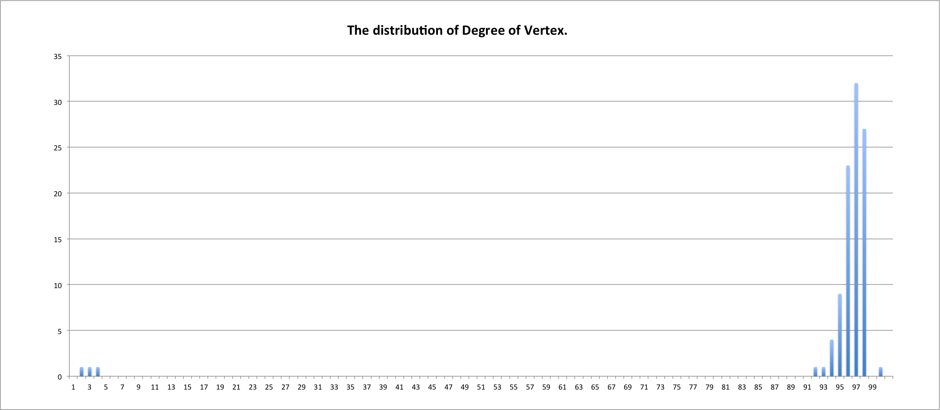

The network distribution graph is created using excel file *output.csv* generated by my java code.

c.

Number of triangle in dataset = 145859.0

Value of nC3 = 166650

The Clustering Coefficient = 0.8752415241524153

From Analyzing all the data I can infer that this is a small community of 100 people in which almost everyone knows each other. Sort of like a small town.

2. (a) Give an example (together with an explanation) of a graph in which more than half of all nodes are gatekeepers.

(b) Give an example (together with an explanation) of a graph in which there are no gatekeepers, but in which every node is a local gatekeeper.

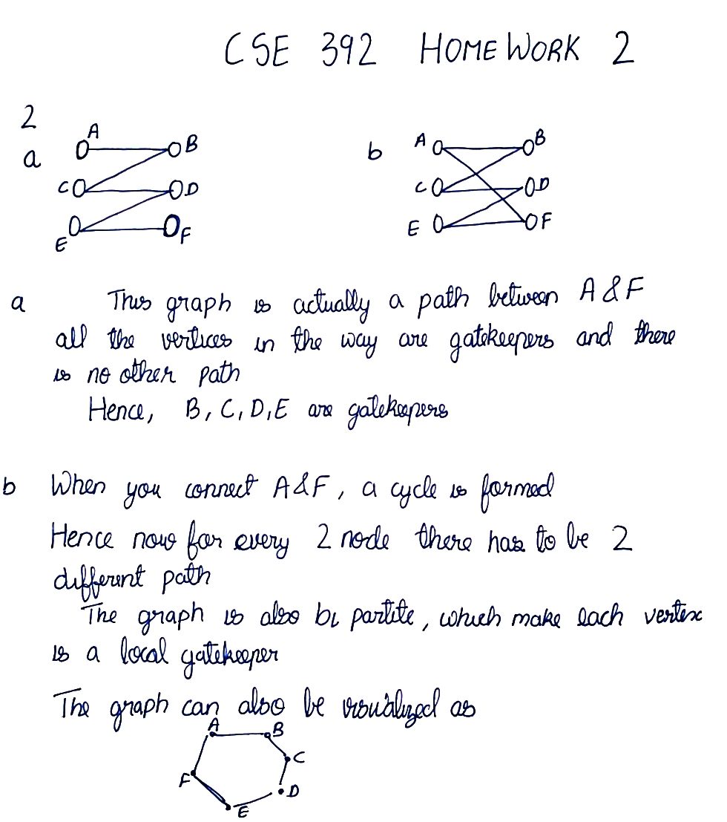

3. In the social network depicted in Figure 3.24, with each edge labeled as either a strong or weak tie, which nodes satisfy the Strong Triadic Closure Property from Chapter 3, and which do not? Provide an explanation for your answer

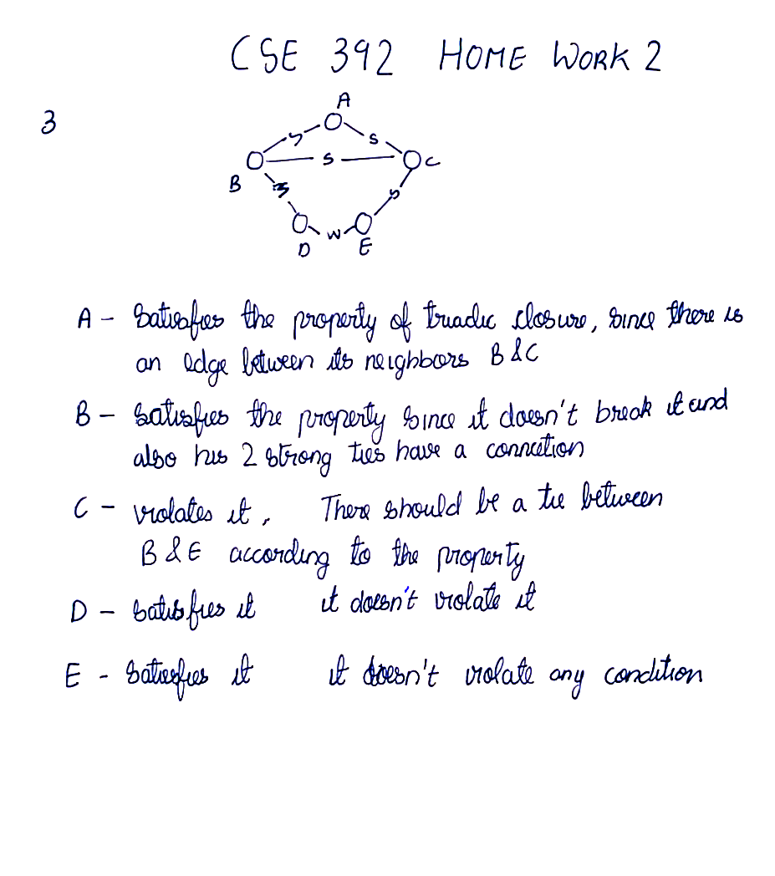

4. Given a bipartite affiliation graph, showing the membership of people in different social foci, researchers sometimes create a projected graph on just the people, in which we join two people when they have a focus in common.

1. Draw what such a projected graph would look like for the example of memberships on corporate boards of directors from Figure 4.4. Here the nodes would be the seven people in the figure, and there would be an edge joining any two who serve on a board of directors together.
2. Give an example of two different affiliation networks — on the same set of people, but with different foci — so that the projected graphs from these two different affiliation networks are the same. This shows how information can be “lost” when moving from the full affiliation network to just the projected graph on the set of people.

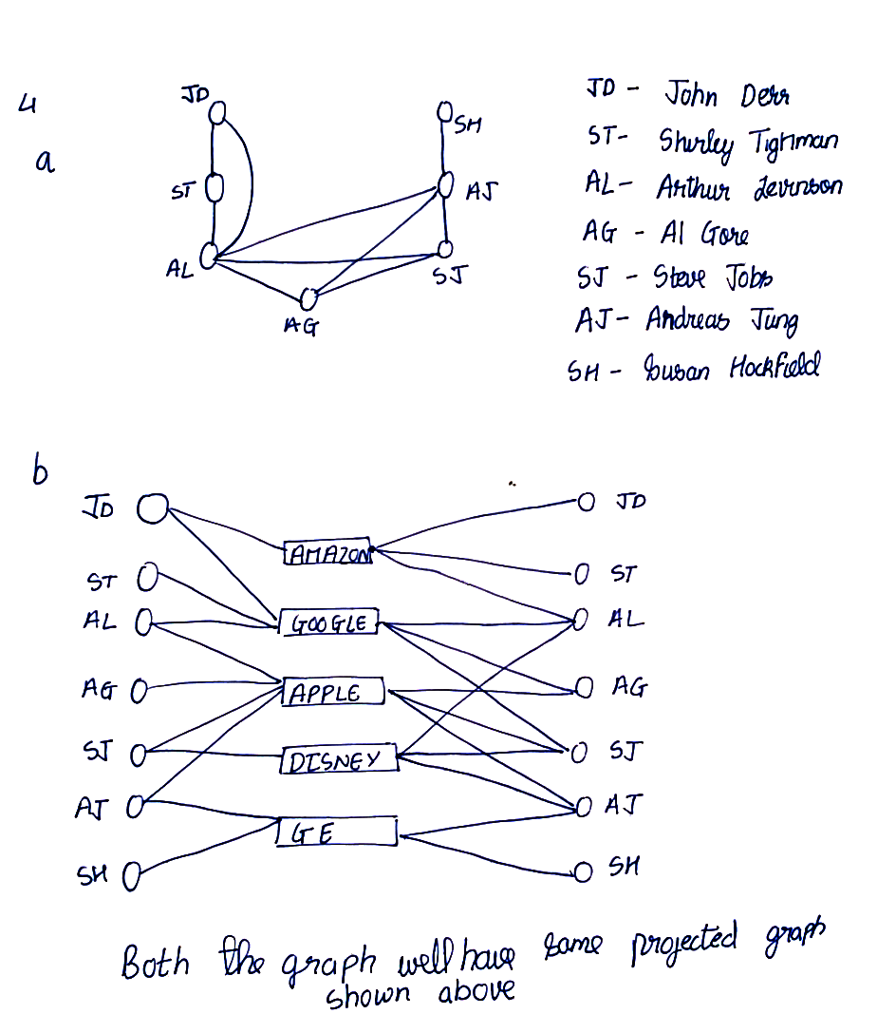

5. Consider the network shown in Figure 5.18: there is an edge between each pair of nodes, with five of the edges corresponding to positive relationships, and the other five of the edges corresponding to negative relationships.

Each edge in this network participates in three triangles: one formed by each of the additional nodes who is not already an endpoint of the edge. (For example, the A-B edge participates in a triangle on A, B, and C, a triangle on A, B, and D, and a triangle on A, B, and E. We can list triangles for the other edges in a similar way.) For each edge, how many of the triangles it participates in are balanced, and how many are unbalanced. (Notice that because of the symmetry of the network, the answer will be the same for each positive edge, and also for each negative edge; so it is enough to consider this for one of the positive edges and one of the negative edges.)

